# **S3 Bucket Creation**

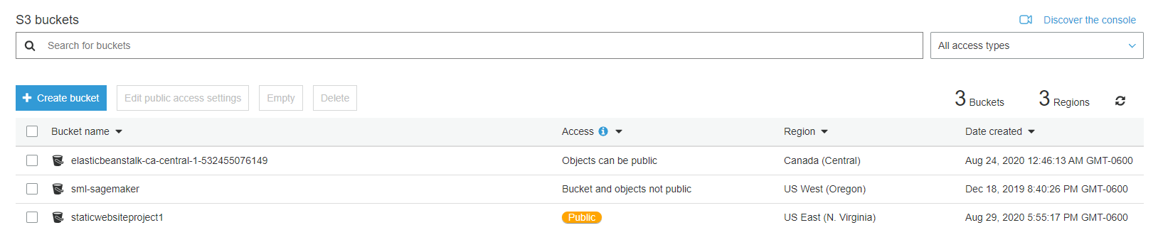

# **S3 Bucket Loaded with content**

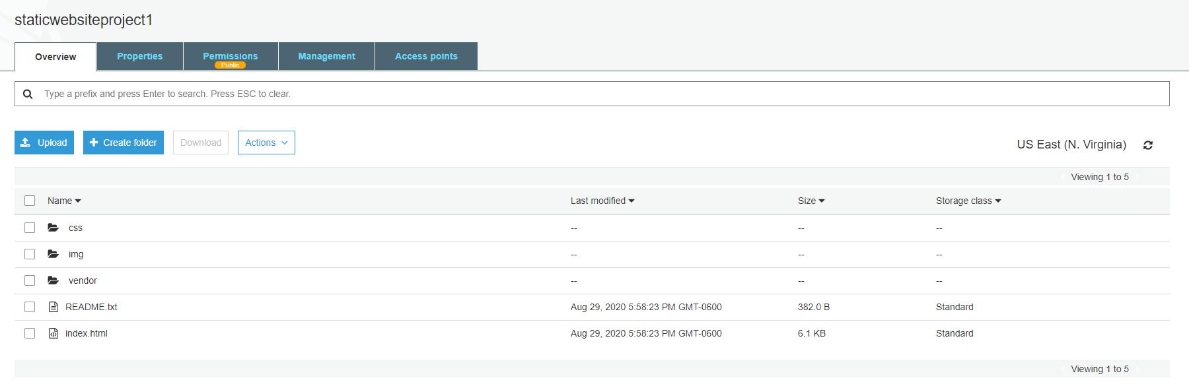

# **Configured for static web hosting**

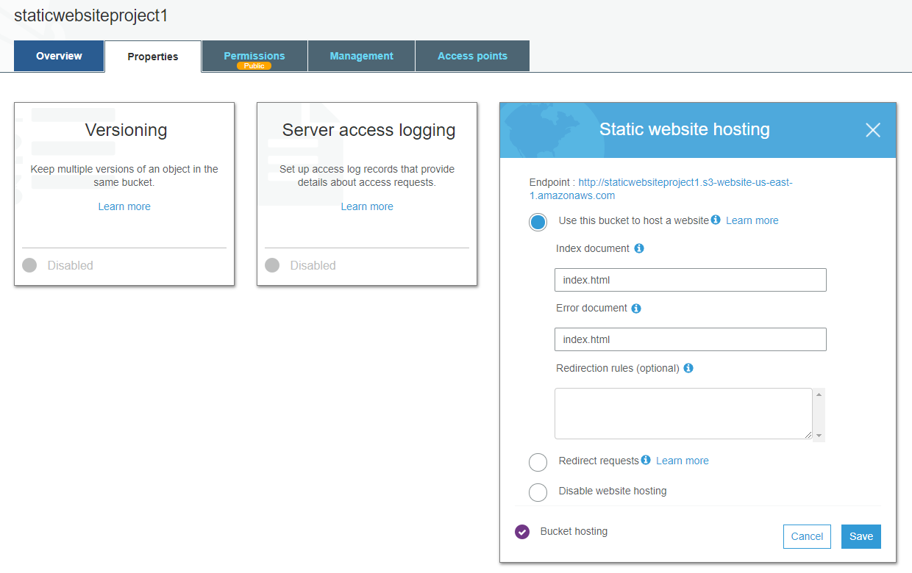

# **IAM Bucket Policy**

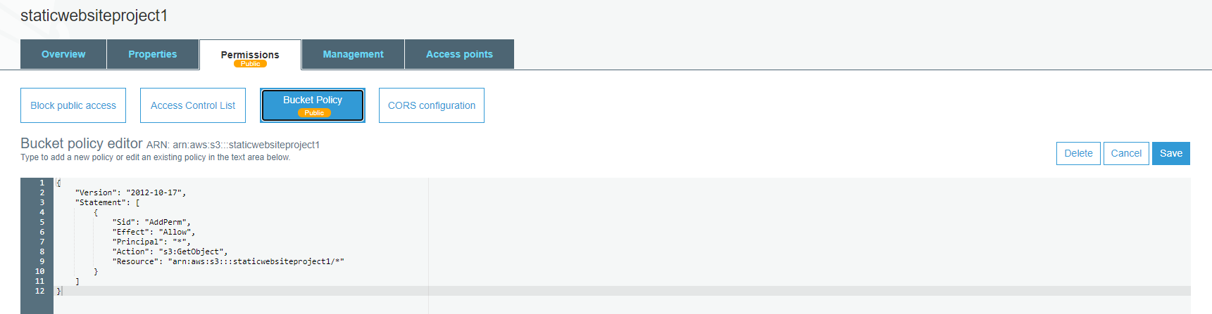

# **CloudFront distributions**

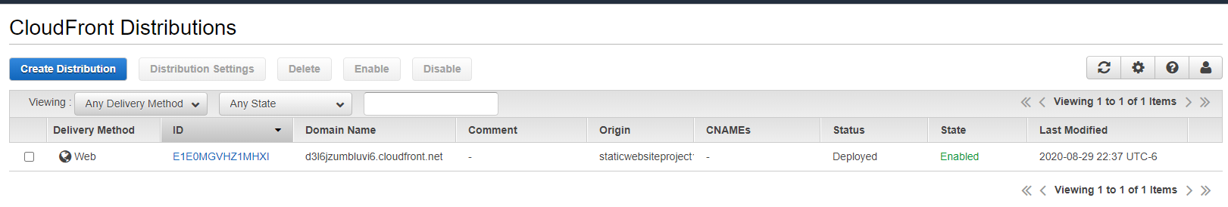

# **URL**

<http://d3l6jzumbluvi6.cloudfront.net/index.html>